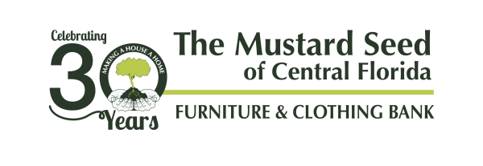
Chairs 4 Charity Sponsorship Levels

Gold: $5,000
Formal recognition of sponsorship throughout the event
Reserved table for eight people
Large logo on event signage
Full-page ad in event program
Large logo and clickable company link on Mustard Seed website
Opportunity to speak at event
Recognition on The Mustard Seed’s Facebook, Twitter and Linkedin pages

Silver: $2,500
Formal recognition of sponsorship at event (one mention)
Reserved table for four people
Medium logo on event signage
Half-page ad in event program
Medium logo and clickable company link on Mustard Seed website
Recognition on The Mustard Seed’s Facebook, Twitter and Linkedin pages

Bronze: $1,000
Recognition in event program and Mustard Seed website
Two seats reserved at shared table
Small logo on event signage
Quarter-page ad in event program
Small logo and clickable company link on Mustard Seed website
Recognition on The Mustard Seed’s Facebook, Twitter and Linkedin pages

CHAIRS 4 CHARITY SPONSORSHIP INFORMATION
Sponsorship Level: | Gold |  | Silver |  |  |  | Bronze
First Name: Last Name:
Email: |  |  | Phone:
Company:
Address:
City: |  | State: |  | Zip code:
Payment Type: Check (Attached) Credit Card
Card Type: | VISA | Master Card |  |  | Discover | AMEX
Card Number: |  |  |  |  |  | Expiration:
*I’m unable to sponsor but wish to support The Mustard Seed in the amount of: $

