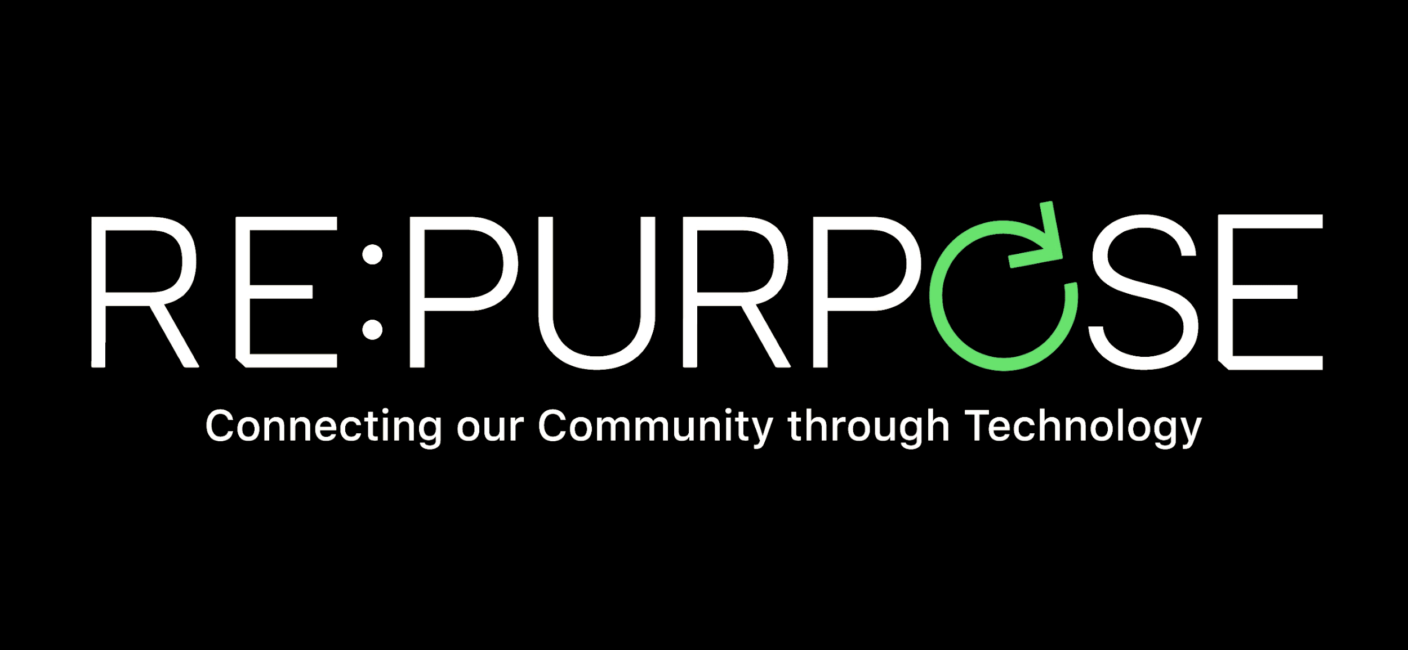

Items We DO Collect
- Working & Broken  - Computers  - Smartphones  - Cell Phones  - Tablets  - Laptops  - Flat Screen TV’s  - Telecom/Phone Systems  - Routers  - MP3 Players  - Audio Equipment  - Accessories  - Digital Cameras | - Flat Screen Monitors  - LCD Screens  - Headphones  - Charging Cables  - Game Consoles & Games  - Controllers  - VCRs and DVD Players  - DVDs  - Projectors  - Power Tools  - Hard Drives  - Battery Backups
Items We DO NOT Collect
- Tube CRT Televisions
- Personal Massagers
- Broken LCD Screens
- Household Electronics
  - Toasters
  - Microwaves
  - Appliances
  - Coffee Makers

There may be items we do accept that are not listed. If you are unsure or have any questions, please email: info@mustardseedfla.org.

The Mustard Seed of Central Florida
12 Mustard Seed Lane, Orlando, Fl 32810
(407) 875-2040
www.mustardseedfla.org

