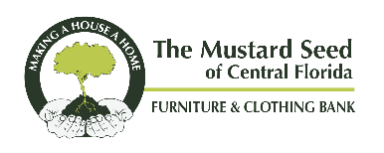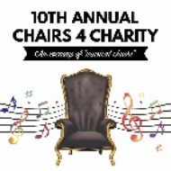
Chairs 4 Charity Sponsorship Levels
Platinum: $10,000
Company logo printed on step-and-repeat banner
Acrylic award on table and to be presented formally at event
Reserved table for 10 people
Full-page ad and one-page company bio in program
Company exhibit booth
Speaking opportunity at event and one-minute marketing video about your company
Large logo on event signage
Large logo and clickable company link on Mustard Seed website
Recognition on The Mustard Seed’s Facebook, Twitter and Linkedin pages

Gold: $5,000
Formal recognition of sponsorship throughout the event
Reserved table for eight people
Large logo on event signage
Full-page ad in event program
Large logo and clickable company link on Mustard Seed website
Recognition on The Mustard Seed’s Facebook, Twitter and Linkedin pages

Silver: $2,500
Formal recognition of sponsorship at event
Reserved table for four people
Medium logo on event signage
Half-page ad in event program
Medium logo and clickable company link on Mustard Seed website
Recognition on The Mustard Seed’s Facebook, Twitter and Linkedin pages

Bronze: $1,000
Formal recognition of sponsorship at event
Two seats reserved at shared table
Small logo on event signage
Quarter-page ad in event program
Small logo and clickable company link on Mustard Seed website
Recognition on The Mustard Seed’s Facebook, Twitter and Linkedin pages

CHAIRS 4 CHARITY SPONSORSHIP INFORMATION
Sponsorship Level: | Gold |  | Silver |  |  |  | Bronze
First Name: Last Name:
Email: |  |  | Phone:
Company:
Address:
City: |  | State: |  | Zip code:
Payment Type: Check (Attached) Credit Card
Card Type: | VISA | Master Card |  |  | Discover | AMEX
Card Number: |  |  |  |  |  | Expiration:
*I’m unable to sponsor but wish to support The Mustard Seed in the amount of: $

